INSTITUTE OF INFORMATION TECHNOLOGY

UNIVERSITY OF DHAKA

CodeLens: An Enhanced Code Visualization and Quality Analysis System
Software Requirements Specification and Analysis Report

Submitted By
Farjana Sarker Naima [ BSSE-1449 ]

Supervised by
Dr. Naushin Nower
Professor
Institute of Information Technology
University of Dhaka

Date of Submission
02 August, 2026

Table of Contents
Table of Contents 1
List of figures 3
List of Tables 3
1. Project Overview 1
1.1 Project Title: CodeLens — An Enhanced Code Visualization and Quality Analysis System 1
1.2 Problem Statement: 1
1.3 Objectives: 1
1.4 Scope 1
1.5 Deliverables: 2
2. Requirements Analysis 3
2.1. Functional Requirements 3
2.1.1. FR-1: Code Upload & Ingestion 3
2.1.2. FR-2: Multi-Language Parsing & Metrics 3
2.1.3. FR-3: 3-Tier Graph Visualization 4
2.1.4. FR-4: Search 4
2.1.5. FR-5: Architecture Pattern Detection 4
2.1.6. FR-6: Layer Violation Analysis 4
2.1.7. FR-7: Code Smell Analysis & AI Refactor Plan 5
2.1.8. FR-8: Change Impact Analysis 5
2.1.9. FR-9: Dependency Risk Scoring 5
2.1.10. FR-10: Dead Code Detection 5
2.1.11. FR-11: Code Metrics Dashboard 6
2.1.12. FR-12: Git History & Evolution Tracking 6
2.1.13. FR-13: Session Management 6
2.2. Non-functional Requirements 6
2.3. Stakeholders 7
2.4. External Interface Requirements 7
2.4.1. User Interfaces 7
2.4.2. Software Interfaces (REST API) 7
2.4.3. Communication Interfaces 8
3. System Modeling 8
3.1. Use Case Diagram and Descriptions 9
UC1 — Upload Source Code 10
UC2 — Browse 3-Tier Code Graph 10
UC3 — Search Code Entities 10
UC5 — Detect Architecture Patterns 10
UC6 — Analyze Layer Violations 10
UC7 — Run Code Smell Analysis 11
UC8 — Request AI Refactor Plan (extends UC7) 11
UC9 — View Dependency Risk Score 11
UC10 — Run Change Impact Analysis (extends UC2) 11
UC11 — Detect Dead Code 11
UC12 — View Git History & Quality Trend 11
UC13 — Manage Session 11
UC14 — Monitor Active Sessions 12
3.2. Activity Diagram 12
Level-1: System Operational Activity Diagram 13
Level-2: Smell-Detection Activity Diagram 14
3.3. Sequence Diagrams 15
3.3.1. Sequence — Upload & Initial Analysis (UC1) 15
3.3.2. Sequence — Drill-Down Navigation (UC2) 16
3.3.3. Sequence — Change Impact Analysis (UC10) 17
3.3.4. Sequence — Code Smell Analysis + AI Refactor Plan (UC7, UC8) 18
3.3.5. Sequence — Session Lifecycle (UC13) 19
4. Data & Information Modeling 20
ER Diagram 20
5. AI Engineering Design 21
5.1. Purpose & Role in the Pipeline 21
5.2. Model & Configuration 21
5.3. Prompt Engineering Design 22
5.4. Design Diagram 22
5.5. Reliability & Fallback Design 23
6. Preliminary Test Plan 23
6.1. Testing Objectives 23
6.2. Test Scope 24
6.3. Test Levels & Types 24
6.4. Test Environment 25
6.5. Sample Test Cases (Preliminary) 25
6.6. Entry / Exit Criteria 26
7. Timeline 26
7.1. Gantt Chart 26
8. Conclusion 27
9. References 28

List of figures
Figure 1: Use Case Diagram 11
Figure 2: Level-1 Activity Diagram 15
Figure 3: Smell-detection Activity Diagram 17
Figure 4: Sequence — Upload & Initial Analysis (UC1) 18
Figure 5: Sequence — Drill-Down Navigation (UC2) 19
Figure 6: Sequence — Change Impact Analysis (UC10) 20
Figure 7: Sequence — Code Smell Analysis + AI Refactor Plan (UC7, UC8) 20
Figure 8: Sequence — Session Lifecycle (UC13) 22
Figure 9: Entity-Relationship (ER) Diagram 23
Figure 10: AI Engineering Pipeline Design 25
Figure 11: Project Gantt Chart 29

List of Tables
Table 1: Non-functional Requirements 8
Table 2: User Class Descriptions 9
Table 3: Stakeholder Descriptions 9
Table 4: REST API Endpoints 9
Table 5: Model & Configuration 24
Table 6: Test Scope 26
Table 7: Test Levels & Types 27
Table 8: Sample Test Cases 28

1. Project Overview

1.1 Project Title: CodeLens — An Enhanced Code Visualization and Quality Analysis System

1.2 Problem Statement:
As codebases grow in size and complexity, developers and technical teams struggle to understand structural relationships, identify risky or poorly maintained code, and assess the impact of changes before making them. Existing tools often support only a single language, lack multi-tier visualization, or fail to combine structural analysis (call graphs, complexity, architecture patterns) with actionable insights (code smells, refactor plans, risk scoring). There is a need for a unified system that can ingest source code in multiple languages, analyze its structure and quality, visualize it at different levels of abstraction, and provide AI-assisted recommendations for improvement.

1.3 Objectives:
- To allow users to upload source code (single files, ZIP archives, or folders) securely and efficiently for analysis.
- To parse and extract structural metrics (functions, complexity, call relationships) across multiple programming languages using Tree-sitter.
- To provide multi-tier (module, file, function, chunk) interactive graph visualizations of the codebase.
- To detect architectural patterns (e.g., MVC, Layered, Clean, Hexagonal) and identify violations of expected layer dependencies.
- To detect code smells at the function, module, and architecture level, and generate AI-driven refactor suggestions.
- To assess change impact and dependency risk to support safer code modifications.
- To detect dead code, compute maintainability metrics, and track code evolution through Git history.
- To manage isolated, secure, and time-bound user sessions for each analysis.

1.4 Scope
The system covers ingestion of source code (single file, ZIP, or directory) up to defined size limits; parsing and metric extraction for nine major programming languages (Python, JavaScript, TypeScript, Java, Go, Rust, C, C++, C#); construction and visualization of call graphs across four tiers; detection of architectural patterns and layer violations; identification of code smells with root-cause analysis; AI-generated refactor plans via an LLM; change impact and dependency risk analysis; dead code detection; a code metrics dashboard; Git history tracking (last 30 commits); and session-based data isolation. The scope excludes analysis of third-party/external library internals, real-time collaborative editing, and automatic code refactoring/execution (the system only recommends, not applies, changes).

1.5 Deliverables:
- A functional web-based platform for code upload and ingestion (file/ZIP/folder support with validation and sanitization).
- A multi-language parsing engine producing per-function and per-file metrics.
- An interactive 3-tier (plus chunk-level) graph visualization module built with Vue Flow and Dagre layout.
- A full-text search feature across functions, files, and modules.
- An architecture pattern detection module with confidence scoring and violation reporting.
- A layer violation analysis report (Controller → Service → Repository → Model).
- A code smell detection engine (function, module, and architecture level) with root-cause ranking and AI-generated refactor plans.
- A change impact analysis module with reverse call graph computation.
- A dependency risk scoring report (High/Medium/Low/None classification).
- A dead code detection report with confidence levels and unused import listing.
- A code metrics dashboard (LOC, complexity, Halstead metrics, Maintainability Index).
- A Git history and evolution tracking module (last 30 commits, paginated).
- A session management system with unique session IDs, data isolation, and auto-expiry.

2. Requirements Analysis

2.1. Functional Requirements

2.1.1. FR-1: Code Upload & Ingestion
- FR-1.1: System shall accept a single source file, a ZIP archive, or a directory (via folder picker).
- FR-1.2: System shall reject files exceeding 2 MB (single file) or uploads exceeding 50 MB / 1000 files in total.
- FR-1.3: System shall sanitize ZIP entries to prevent path traversal ("zip-slip") and skip directories such as node_modules, .git (except for history extraction), venv, dist, build.
- FR-1.4: System shall display upload progress with stage labels.

2.1.2. FR-2: Multi-Language Parsing & Metrics
- FR-2.1: System shall parse Python, JavaScript, TypeScript, Java, Go, Rust, C, C++, and C# using Tree-sitter.
- FR-2.2: System shall extract, per function: name, parameters, line range, cyclomatic complexity, fan-in, fan-out.
- FR-2.3: System shall build an internal call graph using only same-project function calls (external/stdlib calls excluded).
- FR-2.4: System shall classify large files by line count and AST function count, and chunk "god files" into virtual modules for readability.
- FR-2.4.1: A file with ≤ 10,000 lines is classified “normal”. Above that threshold, it is classified by AST-parsed function count: < 3 functions → “data file”; 3–100 functions → “large normal”; > 100 functions → “god file”.
- FR-2.4.2: Recognized generated-file suffixes (.pb.go, etc.) are always classified “god file” regardless of size, unless > 100,000 lines.
- FR-2.4.3: A god file is split into virtual modules: (1) class-based; (2) complexity-based; (3) line-range (fallback).
- FR-2.4.4: Tier-3 requests for chunked god files return the chunk-level graph.
- FR-2.4.5: Chunking is read-only and does not alter parsed function identity.

2.1.3. FR-3: 3-Tier Graph Visualization
- FR-3.1: System shall render Tier-1 (module), Tier-2 (file), Tier-3 (function), and Tier-4 (chunk) graphs using Vue Flow with Dagre auto-layout.
- FR-3.2: System shall support click-to-drill-down and a breadcrumb/back-navigation stack.
- FR-3.3: System shall provide a MiniMap and pan/zoom Controls.
- FR-3.4: System shall visually distinguish node types and risk levels.

2.1.4. FR-4: Search
- FR-4.1: System shall support full-text search across function, file, and module names.
- FR-4.2: Search results shall display entity type, file path, and risk badge.
- FR-4.3: Selecting a result shall load the relevant tier and focus the node.

2.1.5. FR-5: Architecture Pattern Detection
- FR-5.1: System shall detect MVC/MVP, Layered, Clean, Hexagonal, Repository, and common GoF patterns.
- FR-5.2: Each detected pattern shall include a confidence score, evidence, and component-to-layer mapping.
- FR-5.3: System shall list architecture rule violations associated with patterns.

2.1.6. FR-6: Layer Violation Analysis
- FR-6.1: System shall validate calls flow Controller → Service → Repository → Model.
- FR-6.2: Violations shall be reported with source, target, severity, and explanation.
- FR-6.3: Feature requires folder/ZIP upload.

2.1.7. FR-7: Code Smell Analysis & AI Refactor Plan
- FR-7.1: System shall detect function-level smells: Long Method, Too Many Parameters, Dead Code, Feature Envy, Deep Nesting, Switch Smell, Magic Numbers.
- FR-7.2: System shall detect module-level smells: God Module, God Class, Large Module, Lazy Class, Duplicate Code, Data Clumps, Shotgun Surgery.
- FR-7.3: System shall detect architecture-level smells: Circular Dependency, Long Call Chain, Inappropriate Intimacy, Divergent Change.
- FR-7.4: System shall build a smell dependency graph and compute root-cause ranking via BFS and greedy set-cover.
- FR-7.5: On request, system shall call an LLM (Groq llama-3.3-70b-versatile) to generate an executive summary, root cause, and prioritized refactor steps.

2.1.8. FR-8: Change Impact Analysis
- FR-8.1: System shall compute the full reverse call graph (transitive callers) via BFS.
- FR-8.2: Results shall indicate hop-depth and aggregate affected files/modules.
- FR-8.3: System shall render an overlay showing top affected functions.

2.1.9. FR-9: Dependency Risk Scoring
- FR-9.1: System shall classify functions into High (≥10 callers), Medium (3–9), Low (1–2), or None (0) risk based on fan-in.
- FR-9.2: System shall rank and display the top 50 highest-risk functions.

2.1.10. FR-10: Dead Code Detection
- FR-10.1: System shall flag functions with zero fan-in not recognized as entry points.
- FR-10.2: Flagged functions shall carry confidence levels: High (private) or Medium (public).
- FR-10.3: System shall list unused imports per file.

2.1.11. FR-11: Code Metrics Dashboard
- FR-11.1: System shall compute LOC, complexity, Halstead metrics, and Maintainability Index (0–100).
- FR-11.2: System shall report max call-chain depth, circular dependencies, and orphan node count.

2.1.12. FR-12: Git History & Evolution Tracking
- FR-12.1: If .git exists, system shall extract the last 30 commits via git log.
- FR-12.2: System shall report hash, message, author, date, churn, and metrics at that commit.
- FR-12.3: Commit table shall be paginated.

2.1.13. FR-13: Session Management
- FR-13.1: System shall create a unique session (UUID) per user, persisted in sessionStorage.
- FR-13.2: API requests shall carry an X-Session-ID header; data shall be isolated per session.
- FR-13.3: Sessions auto-expire after 3 hours inactivity; explicit cleanup via sendBeacon on tab close.
- FR-13.4: Admin endpoint shall list active sessions.

2.2. Non-functional Requirements
Non-functional requirements for the platform (see Table 1) ensure performance, security, and scalability.
Category | Requirement
Performance | Parse 100 files in <2s; render Tier-1 graph in <5s; sub-second search response.
Security | Zip-slip prevention, per-session data isolation, no server-side code execution.
Reliability | Neo4j failure fallback to in-memory cache.
Usability | Drill-down navigation with breadcrumbs and color-coded risk indicators.
Scalability | Supports 500+ concurrent isolated sessions; dual-caching architecture.
Maintainability | Modular backend architecture separated by detector responsibility.
Table 1: Non-functional Requirements

The various user classes and their interactions with the system are described below (see Table 2).

User Class | Description
Developer / Code Reviewer | Uploads a project to understand structure, locate risky/dead code, and review architecture before refactoring
Software Architect | Uses pattern detection and layer-violation analysis to audit architectural compliance
QA / Tech Lead | Uses code smell, metrics, and Git history panels to track quality trends over time
Developer / Code Reviewer | Monitors active sessions via `/admin/sessions`, ensures cleanup and resource limits
Table 2: User Class Descriptions

2.3. Stakeholders
User Class | Description
Developer / Reviewer | Understands structure and locates risky code before refactoring.
Software Architect | Audits architectural compliance and layer violations.
QA / Tech Lead | Tracks quality trends via Git history and smell analysis.
System Administrator | Monitors active sessions and ensures resource cleanup.
Table 3: Stakeholder Descriptions

2.4. External Interface Requirements

2.4.1. User Interfaces
Single-page application (Vue 3) with a resizable left sidebar (upload, status, search, legend, metrics, git history, smell analysis, risk, dead code, patterns, layer analysis panels) and a main canvas (Vue Flow graph with MiniMap and Controls).

2.4.2. Software Interfaces (REST API)
The system provides a comprehensive REST API for frontend-backend communication (see Table 4).
Method | Endpoint | Purpose
GET | /health | Health check + active session count
POST | /start-session | Create a new session
DELETE | /end-session | Clean up a session
GET | /sessions/info | Current session metadata
GET | /admin/sessions | List all active sessions
POST | /upload | Upload & analyze file/zip/folder
GET | /graph/tier1 | Module-level graph
GET | /graph/tier2/{module_name} | File-level graph
GET | /graph/tier3?file_path= | Function-level graph
GET | /graph/chunk?file_path=&chunk_name= | Function graph for a chunked god file
GET | /graph/files | All-files flat graph
GET | /expand/{function_name} | Direct callers/callees of a function
GET | /risk-score | Dependency risk ranking
GET | /impact-analysis/{function_name} | Reverse call graph / change impact
GET | /dead-code | Unreachable functions & unused imports
GET | /layer-violations | Architectural layer rule violations
GET | /metrics | Aggregated code metrics
GET | /git-history | Commit history with quality estimation
GET | /smell-analysis | Code smell detection + fix plan
POST | /llm-refactor-reason | LLM-based architectural reasoning
GET | /api/patterns/{session_id} | Architecture pattern detection
Table 4: REST API Endpoints

2.4.3. Communication Interfaces
- Frontend ↔ Backend: HTTPS/JSON REST, X-Session-ID custom header for session scoping.
- Backend ↔ Neo4j: Bolt protocol (Neo4j driver) to Neo4j Aura cloud instance.
- Backend ↔ Groq: HTTPS REST call to Groq Chat Completions API.

3. System Modeling

This section outlines the system's behavioral and structural design, including use case diagrams (see Figure 1) for user interactions, sequence diagrams for core process flows, and entity-relationship diagrams for data structure.

3.1. Use Case Diagram and Descriptions
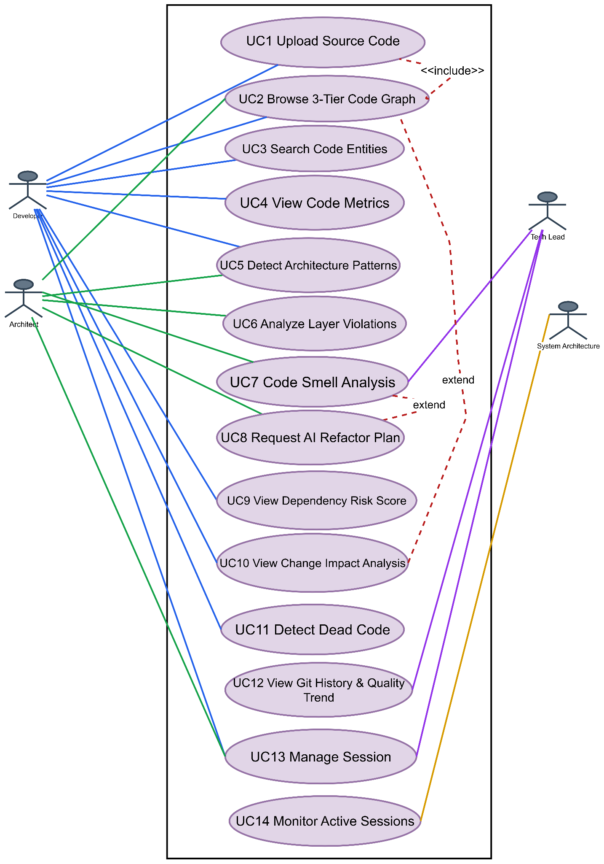
Figure 1: Use Case Diagram

UC1 — Upload Source Code
- Actor: Developer
- Precondition: Active session exists (auto-created on app load).
- Flow: User selects a file, ZIP, or folder → frontend validates → POST /upload → backend extracts, filters ignored paths, parses with Tree-sitter, builds graphs, stores in Neo4j, and returns results.
- Postcondition: Session now holds the parsed project graph; Tier-1 view is rendered.
- Alternate flow: Invalid file type / oversized upload / zip-slip path → reject with error message.

UC2 — Browse 3-Tier Code Graph
- Actor: Developer / Architect
- Flow: User clicks a Module node → GET /graph/tier2/{module_name} → file-level graph rendered. User clicks a File node → GET /graph/tier3?file_path=... → function-level graph rendered. User clicks a Function node → GET /expand/{function_name} → inline callers/callees shown.
- Postcondition: Breadcrumb trail updated; user can navigate back via "← Back".

UC3 — Search Code Entities
- Actor: Developer
- Flow: User types a query in the search box → client-side/REST search returns matching functions/files/modules with risk badge → clicking a result focuses/centers that node in the graph (loading the relevant tier if not visible).

UC5 — Detect Architecture Patterns
- Actor: Architect
- Flow: GET /api/patterns/{session_id} → pattern_detector.py runs rule-based detectors (MVC/MVP, Layered, Clean, Hexagonal, Repository, GoF) against the parsed graph → confidence-scored results with evidence and violations rendered in the Architecture Patterns panel.

UC6 — Analyze Layer Violations
- Actor: Architect
- Precondition: Folder/ZIP upload (multi-file structure required).
- Flow: GET /layer-violations → backend validates architectural flow (Controller→Service→Repository→Model) → violations reported by severity in the Layer Analysis panel.

UC7 — Run Code Smell Analysis
- Actor: Architect / Tech Lead
- Flow: GET /smell-analysis → smell_detector.py evaluates function/module/architecture-level smell rules → smell_graph.py builds a smell dependency graph and root-cause ranking → results (severity chips, ranked files, expandable detail) shown in Smell Analysis panel.

UC8 — Request AI Refactor Plan (extends UC7)
- Actor: Architect
- Flow: User clicks "AI Refactor Plan" → POST /llm-refactor-reason with smell summary → llm_engine.py prompts Groq LLM → response parsed into executive summary, root cause, prioritized steps (pattern, target, effort, risk), and long-term recommendation → rendered in LLM plan box.

UC9 — View Dependency Risk Score
- Actor: Developer
- Flow: GET /risk-score → functions ranked by fan-in into High/Medium/Low/None risk buckets → top functions shown with "Changing this will affect N caller(s)" warning.

UC10 — Run Change Impact Analysis (extends UC2)
- Actor: Developer
- Flow: User hovers/selects a function node → GET /impact-analysis/{function_name} → backend performs BFS over the reverse call graph → affected functions/files/modules with hop-depth returned → impact overlay tooltip rendered on canvas.

UC11 — Detect Dead Code
- Actor: Developer
- Flow: GET /dead-code → backend identifies functions with zero fan-in (not entry points) and lists unused imports per file.

UC12 — View Git History & Quality Trend
- Actor: Developer / Tech Lead
- Precondition: Uploaded ZIP/folder contains a .git directory.
- Flow: GET /git-history → backend runs git log/git show (last 30 commits), estimates LOC/function count/MI per commit → paginated commit table with churn and net delta rendered.

UC13 — Manage Session
- Actor: Any user
- Flow: On app load, frontend calls POST /start-session (or restores ID from sessionStorage); all subsequent requests carry X-Session-ID; on tab close, sendBeacon triggers DELETE /end-session; backend also auto-expires sessions after 3 hours via a background cleanup task.

UC14 — Monitor Active Sessions
- Actor: Administrator
- Flow: GET /admin/sessions → returns list of all active sessions with metadata for operational monitoring.

3.2. Activity Diagram
Activity Diagram is basically a flowchart to represent the flow from one activity to another activity. The activity can be described as an operation of the system. The basic purpose of activity diagrams is to capture the dynamic behavior of the system. It focuses on the execution and flow of the behavior of a system instead of implementation. Activity diagrams consist of activities that are made up of actions that apply to behavioral modeling technology.

Level-1: System Operational Activity Diagram
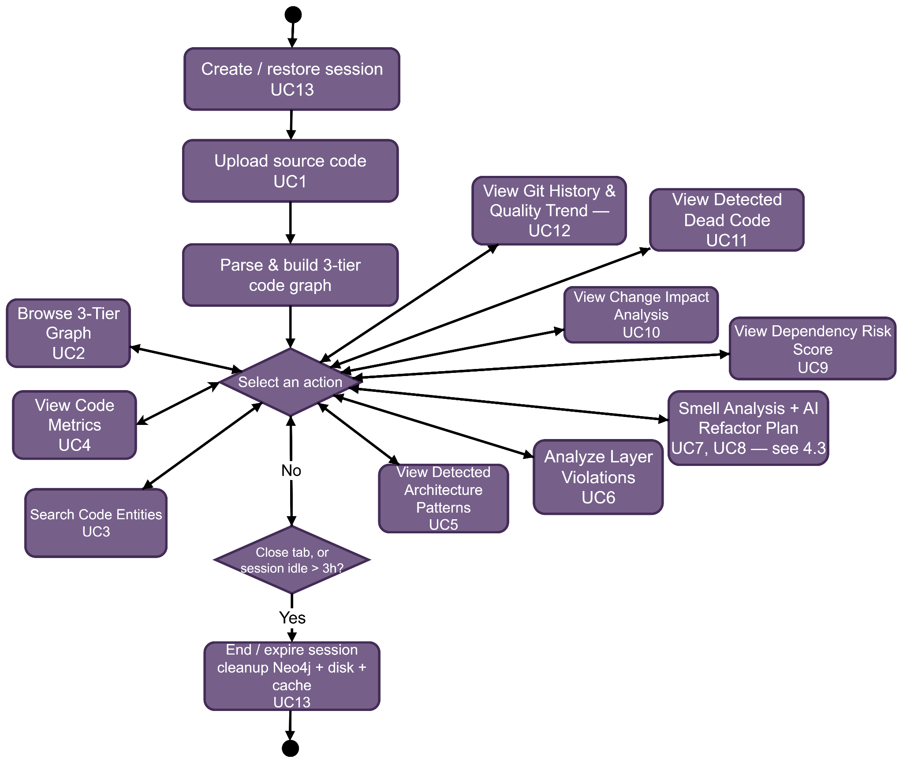
Figure 2: Level-1 Activity Diagram
The Level-1 Activity Diagram provides a comprehensive overview of the system's operational lifecycle. The process begins with the 'Create/Restore Session' action (UC13), establishing a secure, isolated environment for the user. Once the session is established, the user proceeds to 'Upload Source Code' (UC1), which initiates the ingestion and parsing phase. The system then 'Parses & Builds 3-tier Code Graph,' transforming the raw codebase into a structured, searchable model. Following this, the user enters the main interaction loop, represented by the 'Select an action' decision node. From this central hub, users can navigate to various functional capabilities, including 'Browse 3-Tier Graph' (UC2), 'Search Code Entities' (UC3), 'Detect Architecture Patterns' (UC5), 'Analyze Layer Violations' (UC6), 'Smell Analysis + AI Refactor Plan' (UC7, UC8), 'View Dependency Risk Score' (UC9), 'Run Change Impact Analysis' (UC10), 'Detect Dead Code' (UC11), and 'View Git History & Quality Trend' (UC12). This loop continues until the system detects inactivity beyond a 3-hour threshold or the user closes the tab, triggering the final 'End/Expire Session' node, which ensures the cleanup of data in Neo4j, cache, and temporary disk storage.

Level-2: Smell-Detection Activity Diagram
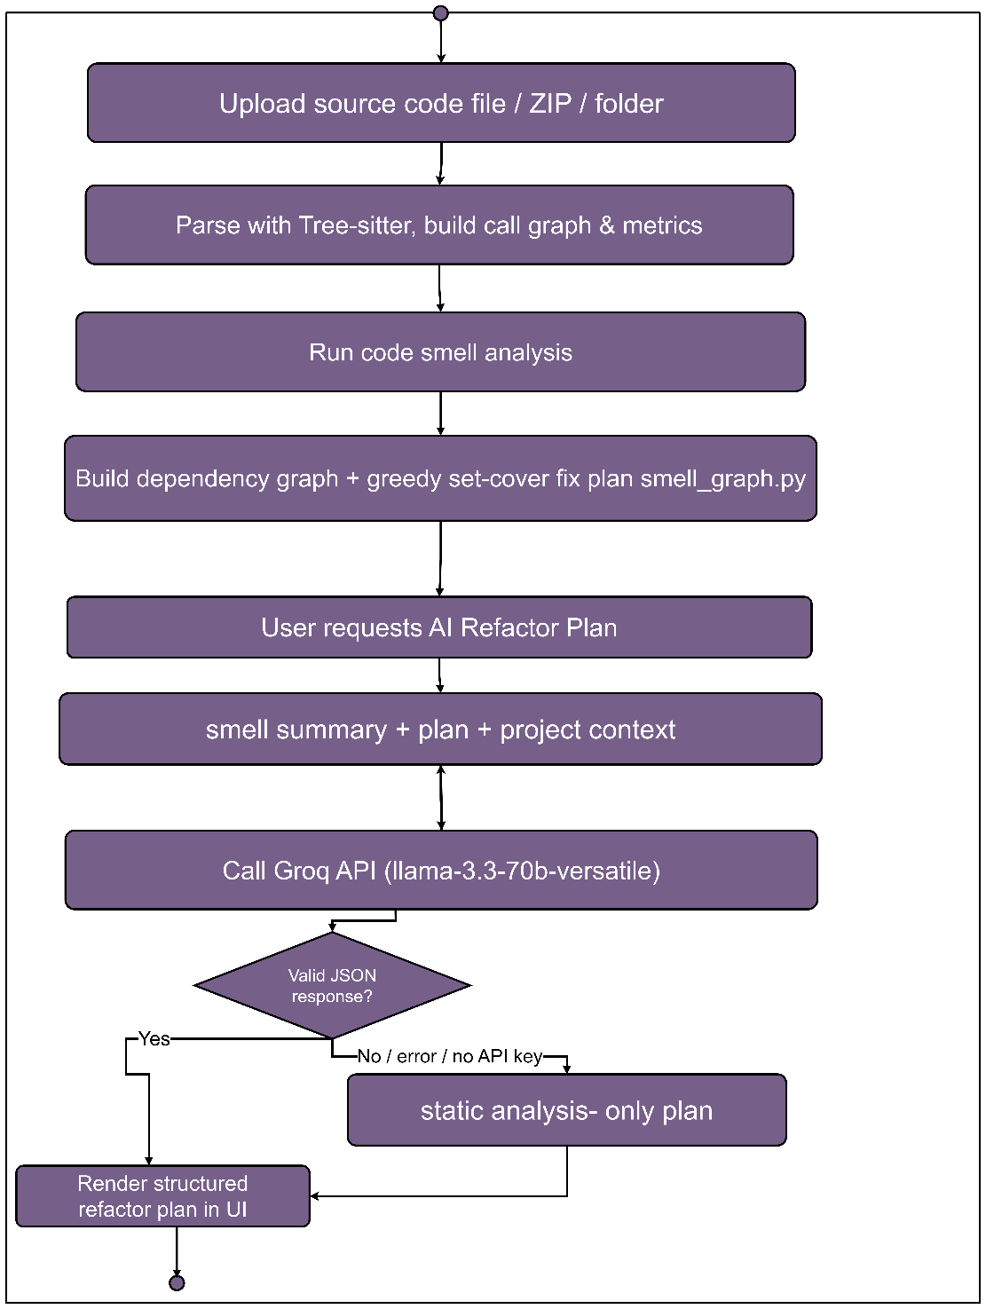

Figure 3: Smell-detection Activity Diagram
This diagram details the logic flow of the code smell analysis, encompassing parsing, smell detection, and the integration of AI-assisted refactor planning.

3.3. Sequence Diagrams

3.3.1. Sequence — Upload & Initial Analysis (UC1)
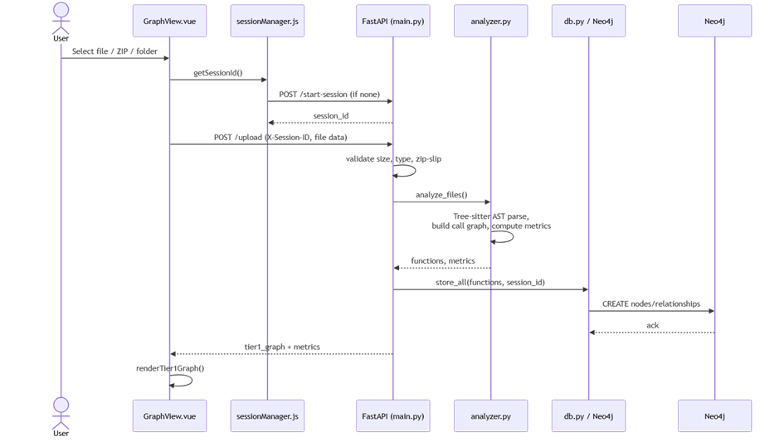
Figure 4: Sequence — Upload & Initial Analysis (UC1)
This diagram illustrates the initial code ingestion process. The user initiates a file upload through GraphView.vue, which handles session verification before passing the data to FastAPI. The backend processes the files using analyzer.py for AST parsing and metric extraction, subsequently storing the structural data in Neo4j to enable the rendering of the initial Tier-1 visualization.

3.3.2. Sequence — Drill-Down Navigation (UC2)
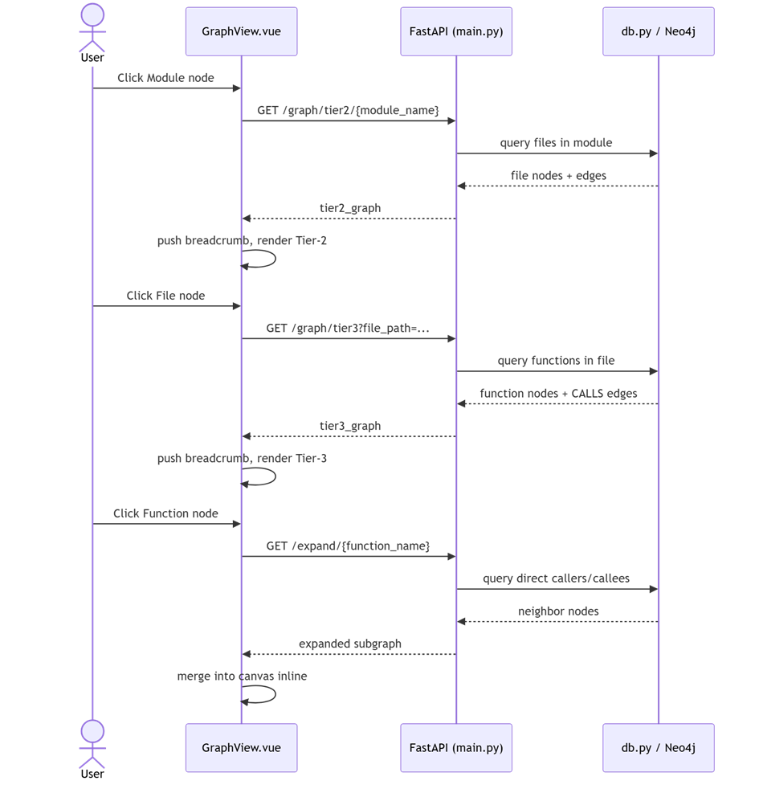
Figure 5: Sequence — Drill-Down Navigation (UC2)
This diagram details the drill-down navigation flow. When a user interacts with nodes (Module or File), GraphView.vue requests specific graph tiers from the backend, which queries the Neo4j database for related entities and relationships. The frontend then updates the display, pushes breadcrumbs, and renders the requested tier.

3.3.3. Sequence — Change Impact Analysis (UC10)
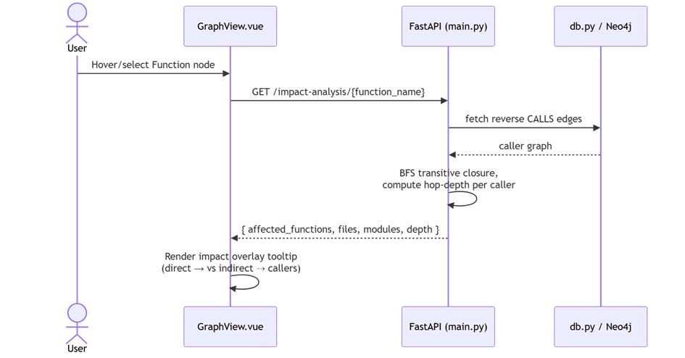
Figure 6: Sequence — Change Impact Analysis (UC10)
This diagram outlines the process for change impact analysis. Upon selecting a function node, the frontend requests impact data from FastAPI, which retrieves the reverse call graph from Neo4j. The backend then performs a BFS traversal to compute hop-depths, allowing the frontend to render an overlay visualizing the ripple effect of potential changes.

3.3.4. Sequence — Code Smell Analysis + AI Refactor Plan (UC7, UC8)
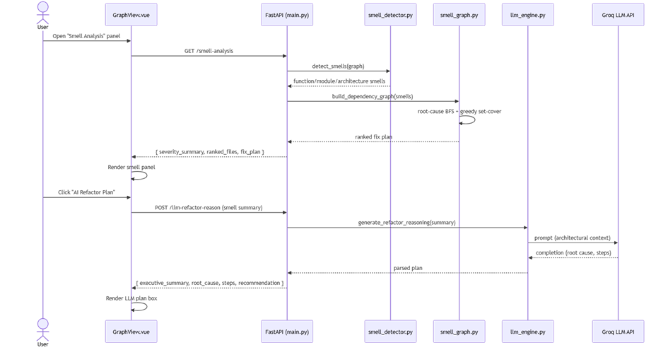
Figure 7: Sequence — Code Smell Analysis + AI Refactor Plan (UC7, UC8)
This diagram shows the two-stage flow for code smell analysis. First, the user triggers a general analysis which runs through the smell detector and graph builder. Second, upon request, the system invokes the llm_engine.py to process the smell summary with the Groq LLM API, ultimately returning a structured refactor plan to the UI.

3.3.5. Sequence — Session Lifecycle (UC13)
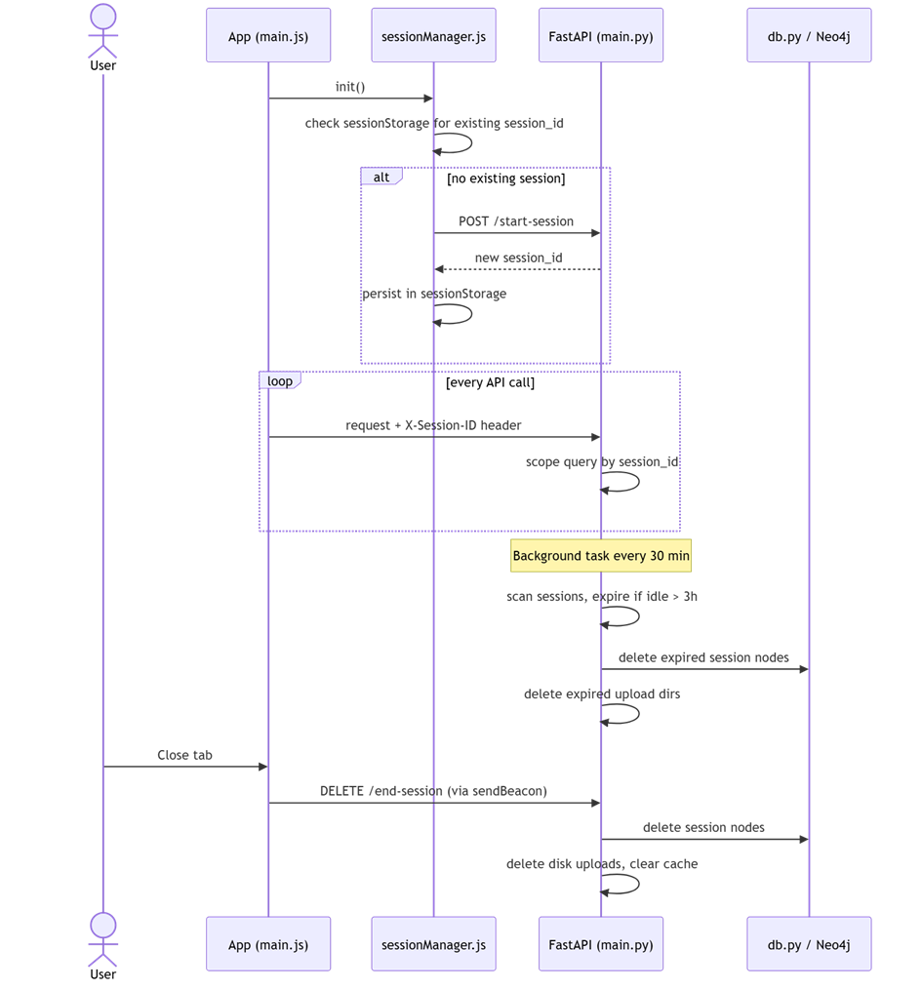
Figure 8: Sequence — Session Lifecycle (UC13)
This diagram depicts the automated session lifecycle management. It highlights the initialization of a session ID upon app load, the inclusion of this ID in every API request for data isolation, and the automated cleanup processes triggered by either tab closure or inactivity timeouts to ensure efficient resource management.

4. Data & Information Modeling

ER Diagram
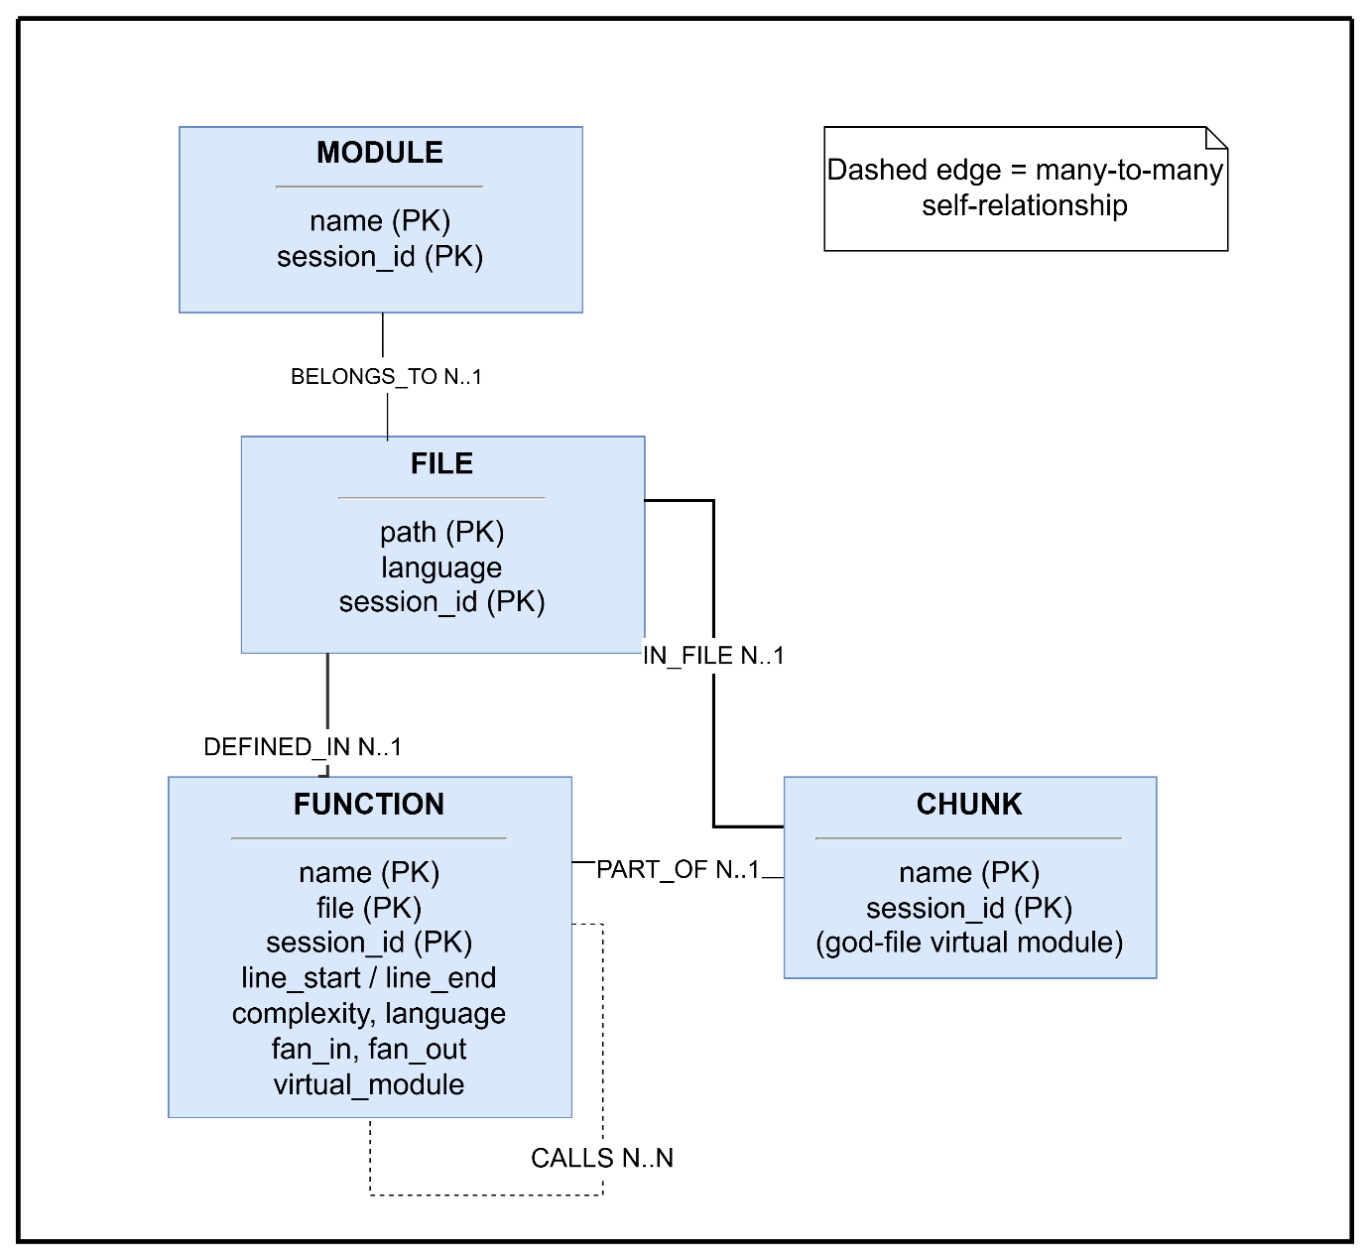

Figure 9: Entity-Relationship (ER) Diagram
Notes:
- All nodes are tagged with session_id to isolate per-user data within the shared Neo4j instance.
- CALLS is a many-to-many self-relationship on FUNCTION, carrying frequency and line properties.
- VIRTUAL_MODULE exists only for "god files" that are split for readability; it sits between FILE and FUNCTION.

5. AI Engineering Design

5.1. Purpose & Role in the Pipeline
Static analysis (smell_detector.py + smell_graph.py) determines what is architecturally wrong and produces a preliminary, purely rule-based fix plan via a greedy set-cover ordering over the smell dependency graph. The AI layer (llm_engine.py) is invoked only on explicit user request (UC8) to reason about why the smells occurred and how to fix them with architectural judgment — it never runs automatically and never replaces the static analysis, only enriches it.
Two independent LLM-backed capabilities exist:
- get_refactor_plan() — turns the smell summary + preliminary plan into a prioritized, risk-assessed architectural refactor plan (UC8).
- get_code_preview() — given one smell, generates a short before/after code snippet illustrating the suggested fix.

5.2. Model & Configuration
The model and configuration details are summarized below (see Table 5).
Setting | Value
Provider | Groq Chat Completions API
Model | llama-3.3-70b-versatile (env override: GROQ_MODEL)
Temperature | 0.20 (low — favors deterministic, structured output over creativity)
Response format | Forced JSON object (response_format={"type":"json_object"})
Credentials | GROQ_API_KEY (loaded from Backend/.env)
Table 5: Model & Configuration

5.3. Prompt Engineering Design
Data-only input contract — the LLM never receives raw source code or file contents. It is deliberately restricted to structured, pre-computed data:
- Smell summary (total smell count, per-type counts, top root causes)
- Preliminary minimal-fix plan (top 6 steps from the static greedy set-cover algorithm)
- Project scale context (file/function counts, average complexity, max call-chain depth)
- This keeps the prompt small and token-efficient, and prevents the model from "inventing" issues not grounded in the static analysis.
System prompt hard rules (_SYSTEM in llm_engine.py) constrain the model to:
- Identify the single primary root cause driving the smell cluster, not a list of unrelated issues.
- Recommend only structural/architectural refactors — never trivial stylistic cleanups.
- Justify each step's ordering by its downstream impact on other smells.
- Use precise GoF/Fowler pattern names (Extract Class, Move Method, Facade, etc.) rather than vague advice.
- Optimize for minimal change with maximum smell reduction.
- Return strictly valid, compact JSON — no markdown or prose outside the JSON object.
Output contract — the model must return: executive summary, primary root cause, smell root causes (primary/secondary), refactor plan(each with priority, pattern, target, what to do, why this first, resolves smells, estimated effort, risk, risk reason), and long term recommendation.

5.4. Design Diagram
The pipeline design is visualized below (see Figure 8).
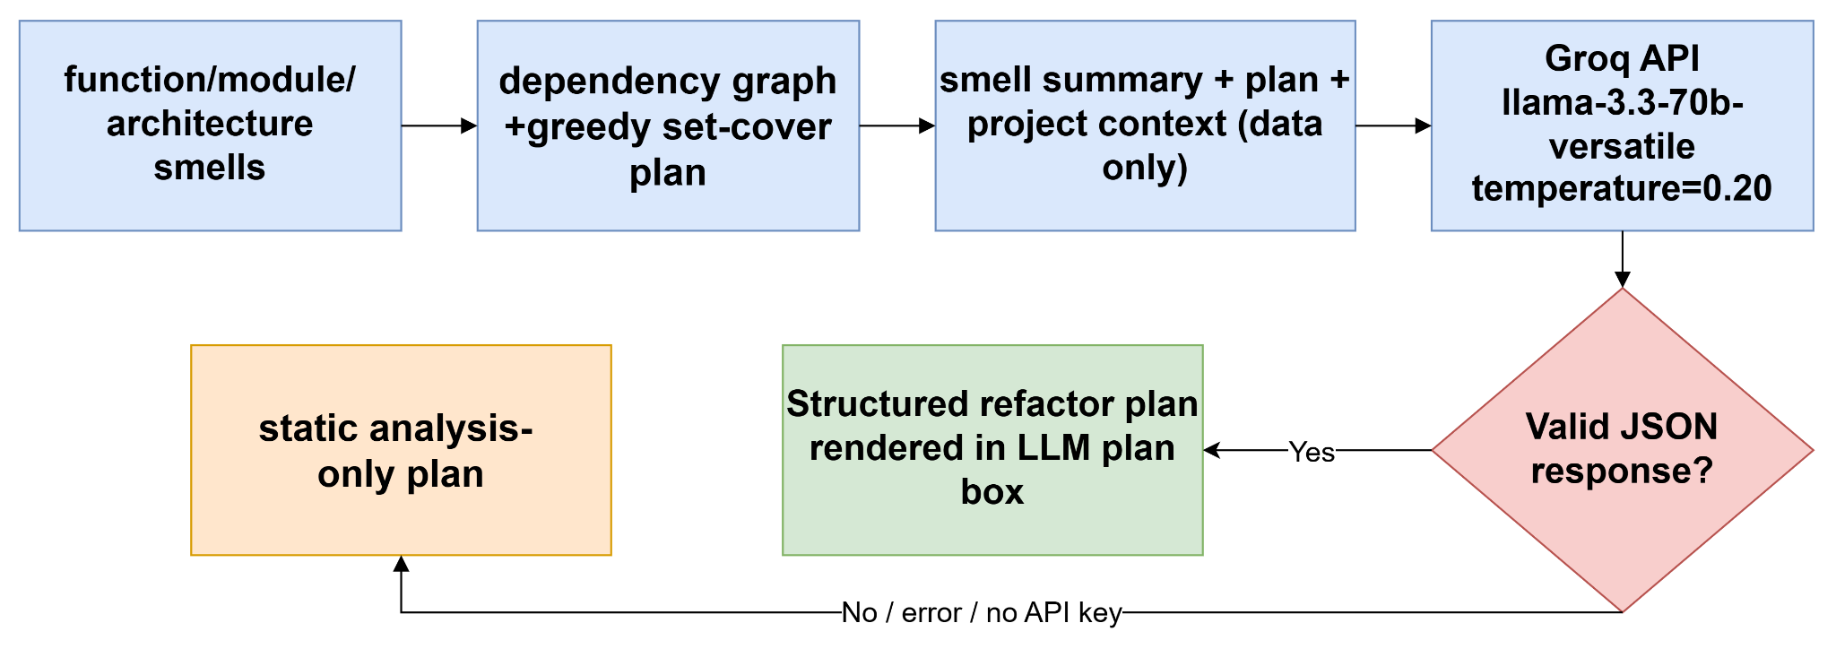
Figure 10: AI Engineering Pipeline Design

5.5. Reliability & Fallback Design
The AI Refactor Plan feature is designed to degrade gracefully rather than fail. If the API key is missing, the groq package isn't installed, the API call raises an exception, or the response fails JSON parsing, get_refactor_plan() returns a deterministic fallback plan derived purely from the static analysis (tagged _source: "static_analysis_fallback" with an _error field for diagnostics), so the Smell Analysis panel always has a fix plan to display, with or without the LLM (FR-7.5).

6. Preliminary Test Plan

6.1. Testing Objectives
- Verify multi-language parsing (Python, JavaScript, TypeScript, Java, Go, Rust, C, C++, C#) produces correct function inventories, call graphs, and complexity metrics.
- Verify the 3-tier drill-down (Module → File → Function → Chunk) stays consistent — correct breadcrumb state, correct scoping of child nodes to their parent.
- Validate architecture pattern detection, layer-violation analysis, code smell detection, dead-code detection, and risk scoring against known/representative code fixtures.
- Verify the AI Refactor Plan gracefully falls back to the static-analysis-only plan when the Groq API is unavailable or misconfigured (Section 7.5).
- Verify session isolation: two concurrent sessions never see each other's uploaded data, graphs, or analysis results.
- Verify upload validation and security controls: zip-slip path rejection, oversized file/archive rejection, disallowed directory filtering (node_modules, venv, etc.).
- Verify the system meets the performance targets defined in the Non-Functional Requirements (Section 14).

6.2. Test Scope
The defined test scope ensures all critical modules are validated while respecting project boundaries (see Table 6).
In Scope | Out of Scope
All REST endpoints in main.py | Load/stress testing beyond the 500-concurrent-session NFR target
Frontend drill-down, search, and panel rendering (Vue Flow) | Cross-browser pixel-perfect UI testing
Static analyzers: analyzer.py, pattern_detector.py, smell_detector.py, smell_graph.py | Real-time multi-user collaborative editing (explicitly out of scope, Section 1.2)
AI Refactor Plan + its fallback path (llm_engine.py) | Third-party Groq model quality/accuracy evaluation
Session lifecycle (creation, expiry, cleanup) | CI/CD pipeline integration (not yet part of the project)
Table 6: Test Scope

6.3. Test Levels & Types
The testing strategy employs multiple levels and techniques to ensure quality (see Table 7).

Level | Technique | Notes
Unit | pytest, function-level assertions | Analyzer functions (complexity calc, fan-in/out, smell rules) tested against small synthetic code snippets
Integration | FastAPI TestClient | Upload → parse → store → query round-trip per endpoint
System / End-to-End | Manual, browser-driven | Full upload-to-analysis walkthroughs per the existing TESTING_VERIFICATION_GUIDE.md pattern
Security | Manual + targeted unit tests | Zip-slip payloads, oversized uploads, symlink entries
Performance | Manual timing against NFR targets | Tier-1/2/3 response time, search latency, god-file chunking time
Table 7: Test Levels & Types

6.4. Test Environment
- Backend: local FastAPI + Uvicorn instance (python -m uvicorn main:app --reload).
- Frontend: local Vite dev server (npm run dev).
- Database: Neo4j Aura test instance, with in-memory cache fallback verified by simulating a Neo4j outage.
- AI: a valid GROQ_API_KEY for the success path, and a deliberately unset/invalid key to exercise the fallback path.

6.5. Sample Test Cases (Preliminary)
Preliminary test cases cover high-risk user flows and security requirements (see Table 8).

ID | Feature / UC | Scenario | Expected Result
TC-01 | UC1 Upload | Upload a ZIP with a path-traversal (`../../`) entry | Upload rejected with a zip-slip error; no files written outside the target directory
TC-02 | UC1 Upload | Upload a folder exceeding 50 MB / 1000 files | Upload rejected with a size/count-limit error
TC-03 | UC2 Browse | Click a Module → File → Function in sequence | Correct Tier-2/Tier-3 graphs returned; breadcrumb reflects the path; "← Back" restores the prior tier
TC-04 | UC7/UC8 Smell + AI | Trigger AI Refactor Plan with GROQ_API_KEY unset | Response has _source: "static_analysis_fallback"; UI still renders a complete plan
TC-05 | UC10 Impact Analysis | Request impact analysis for a function with 3 transitive callers | Response lists all 3 callers with correct hop-depth (direct vs. indirect)
TC-06 | UC13 Session | Leave a session idle past the 3-hour expiry window | Background cleanup task removes the session's Neo4j nodes, cache, and disk uploads on its next run
TC-07 | UC14 Admin | Call GET /admin/sessions` | Returns metadata for every currently active session
Table 8: Sample Test Cases

6.6. Entry / Exit Criteria
- Entry: Feature's endpoint(s) implemented and manually reachable; test fixtures (sample source files) prepared per language.
- Exit: All sample test cases above pass; no open Critical/High severity defects; performance targets in Section 14 met on the reference test environment.

7. Timeline

7.1. Gantt Chart

The project timeline is visualized below (see Figure 9).
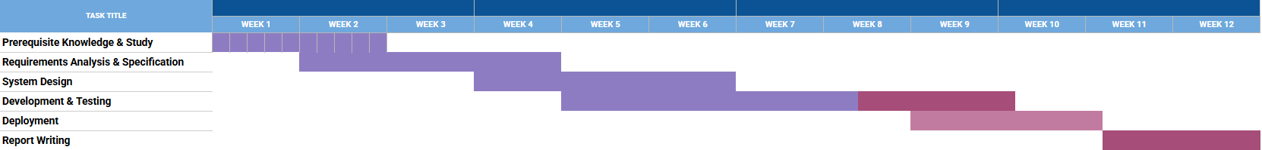
Figure 11: Project Gantt Chart

Legend
- Purple: Completed Tasks (Prerequisite Knowledge & Study, Requirements Analysis & Specification, System Design, Development & Testing).
- Pink/Red: Pending/Future Tasks (Deployment, Report Writing).

8. Conclusion
This report has presented a complete requirements specification and analysis for CodeLens — An Enhanced Code Visualization and Quality Analysis System. Starting from a bounded problem statement and scope, thirteen groups of functional requirements (FR-1 to FR-13) were derived along with measurable non-functional targets, and these were translated into concrete engineering models: fourteen use cases, two activity diagrams, five sequence diagrams, and an entity-relationship model covering sessions, modules, files, functions, call relationships, smells and commits.
The distinguishing contribution of CodeLens is its combination of three capabilities normally offered by separate tools: language-agnostic parsing across nine languages using Tree-sitter, a four-tier interactive visualization (module → file → function → chunk) that keeps even very large "god" files navigable, and a quality layer that ranks code smells by root cause and converts that ranking into a prioritized, LLM-generated refactor plan. The AI layer is designed as an enhancement rather than a dependency — when the Groq API is unavailable, a deterministic static-analysis plan is returned instead, so the system's core value is preserved under failure. Known boundaries remain: third-party library internals are not analysed, refactorings are recommended but never applied, and Git tracking is limited to the last thirty commits.
With the preliminary test plan and timeline in place, the prerequisite study, requirements analysis, system design, and development and testing phases are complete, leaving deployment and final report writing. Future work will focus on widening language coverage, CI/CD integration for automatic per-commit quality tracking, and empirical evaluation of the generated refactor plans with practising developers. On this basis, the requirements documented here are considered stable and sufficient to proceed to full implementation.

9. References
[1] ISO/IEC/IEEE 29148:2018, Systems and Software Engineering — Life Cycle Processes — Requirements Engineering, International Organization for Standardization, Geneva, Switzerland, 2018.
[2] M. Fowler, Refactoring: Improving the Design of Existing Code, 2nd ed. Boston, MA, USA: Addison-Wesley, 2018.
[3] E. Gamma, R. Helm, R. Johnson, and J. Vlissides, Design Patterns: Elements of Reusable Object-Oriented Software. Reading, MA, USA: Addison-Wesley, 1994.
[4] R. C. Martin, Clean Architecture: A Craftsman's Guide to Software Structure and Design. Boston, MA, USA: Prentice Hall, 2017.
[5] A. Cockburn, "Hexagonal Architecture," 2005. [Online]. Available: https://alistair.cockburn.us/hexagonal-architecture/ [Accessed: 02-Aug-2026].
[6] T. J. McCabe, "A complexity measure," IEEE Transactions on Software Engineering, vol. SE-2, no. 4, pp. 308–320, Dec. 1976.

